Working With Dataset

# Average Exercise Angina During Chest Pain

|  |  |
| --- | --- |
| Team ID | PNT2022TMID04459 |
| Project Name | Visualizing and Predicting Heart Diseases with an Interactive Dashboard |

## Visualization:

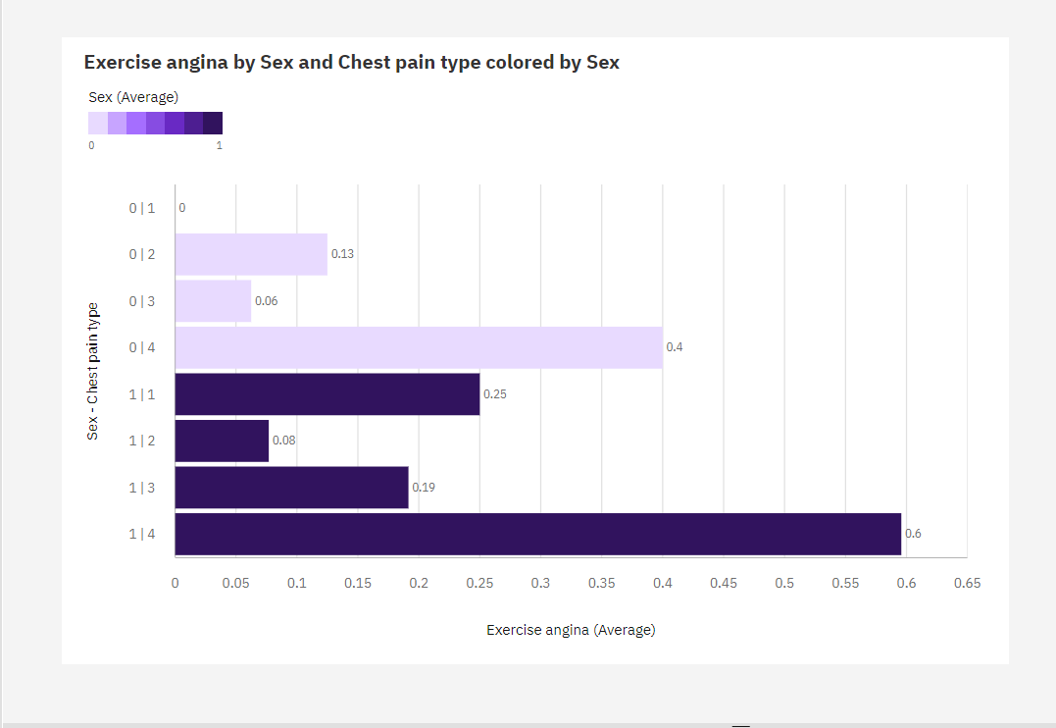

1. The most common value of **Sex - Chest pain type** is 0|2, occurring 183 times, which is 67.8 % of the total.
2. Over all **sex - chest pain types**, the average of **Exercise angina** is 2.174.
3. The average values of Exercise angina range from 0, occurring when Sex - Chest pain type is 0|1, to 3, when Sex - Chest pain type is 0|1.